**Converting Stations from EMS to DMS**

**Abstract:**

This guide will go through the steps of batching out a station residing in the EMS Psa views to convert them into the DMS views and batched into a DMS system.

This guide does NOT go through batching in the circuits for the substation into the system.

This guide is in alpha. All tools have yet to be finalized. Once finalized the guide will be updated and locations of files and scripts will be moved/changed.

**Setup:**

You should have a copy of the ‘DMS Conversion’ folder stored locally on your computer/jumpbox.

Because of the risk of files on the jumpbox being deleted without warning, make sure you back up any files you save on a local machine.

**Procedure:**

**The procedure will batch out and convert TORTILLA 33KV, bus number 1515 as a demonstration.**



**Figure 1:** Log into dmsdt6ap01.

Use the command ‘rsh emsdt2ap01’

Go to /xahome/xa21/Ben/ndbtool/ on emsdt2ap01

Run the command ‘bash 011_BatchStationForDMS.sh’ in emsdt2ap01

Type in the bus number(s) of the station(s) you want to batch out to the script on emsdt2ap01

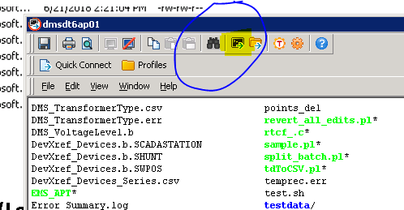

**Figure 2A:** The file explorer is a tool that provides a user interface to navigate the linux file system. We will use this to copy necessary files to and from the remote desktop where the conversion tool is located to the dmsdt6 box. It can be opened by clicking on the circled button in the figure above located in the ssh window.

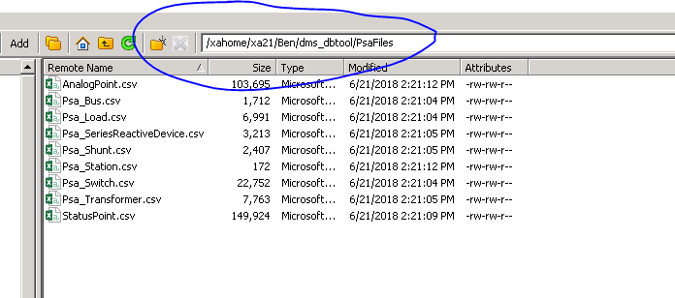

**Figure 2:** Open the **file explorer (Located in figure 2A)** in ssh for dmsdt6ap01 and navigate to /xahome/xa21/Ben/dms_dbtool/PsaFiles on dmsdt6ap01

Inside you should see the substation files in csv format. Verify the timestamp is recent for the csv files.

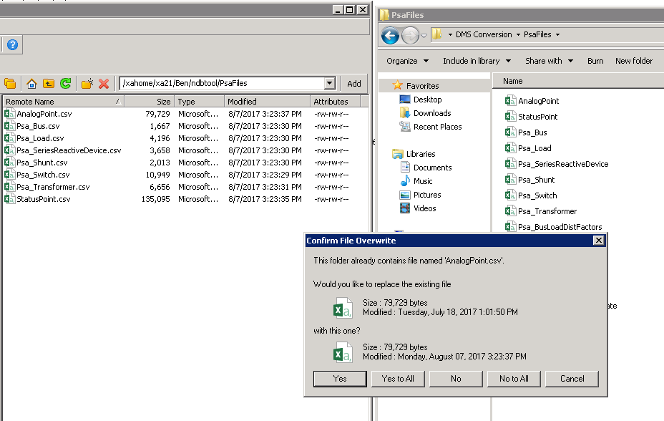

**Figure 3:** Drag and drop the files from dmsdt6ap01 into the ‘PsaFiles’ folder in the ‘DMS Conversion’ folder.

You will be prompted to ask if you want to overwrite the files already in the folder.

Select **‘Yes to All’** to overwrite the previous files.

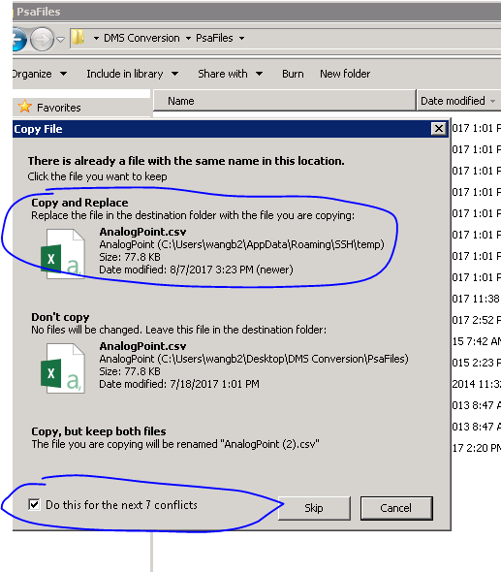

**Figure 3a:** **After you select ‘Yes to all’**, select the checkmark circled above, and **select ‘Copy and Replace’** as the option.

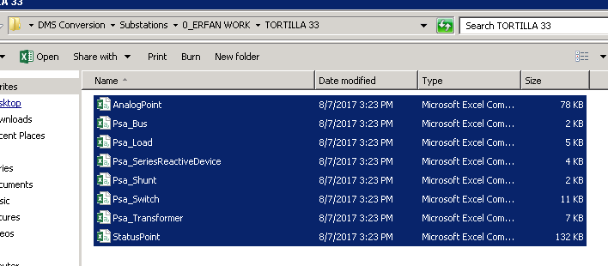

**Figure 4:** (OPTIONAL)

For backup purposes, you may also want to create a folder somewhere to store the substation files locally so you do not have to repeat the batch out process again. 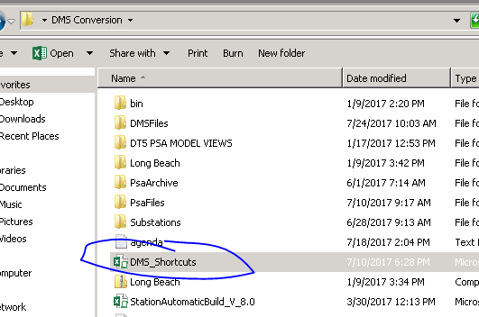

**Figure 5:** Once all of the files have been copied over into the ‘PsaFiles’ folder, open the ‘DMS_Shortcuts’ file in the ‘DMS Conversion’ folder.

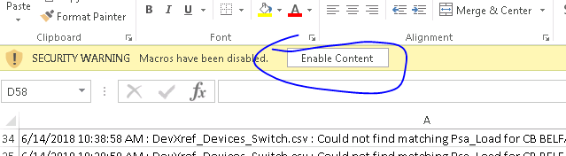

**Figure 5A:** When the DMS_Shortcuts file is open, if a yellow bar shows that macros have been disabled. Press the ‘Enable Content’ button to enable macros. If no bar appears, you can ignore this step.

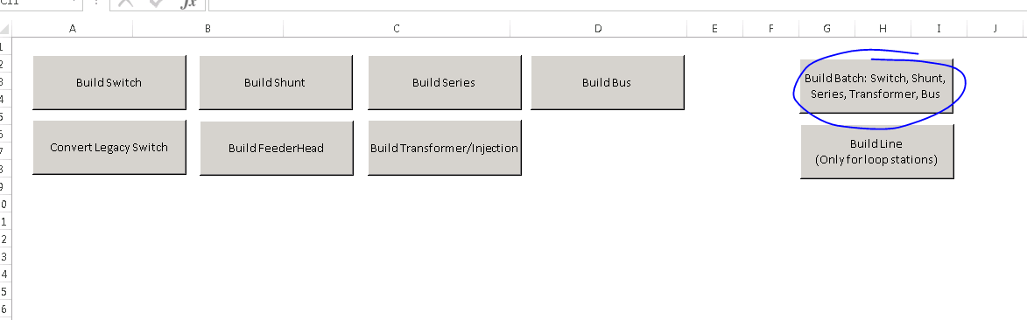

Go to the sheet in the excel file named ‘LAUNCHER’ and press the button circled above.

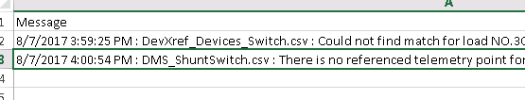

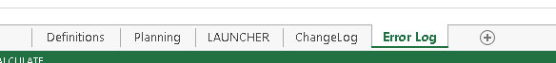

**Figure 9:** When an error occurs, you will be moved to the ‘Error Log’ sheet. You can review all of the errors afterwards. Some error messages are just warnings which can be disregarded. It is up to the user to determine which needs to be investigated.

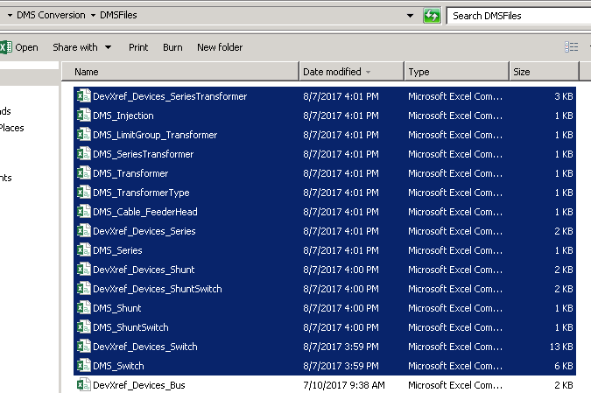

**Figure 10:** Once all of the files have been converted, you can check the ‘DMSFiles’ folder and copy all of the files with an updated time stamp.

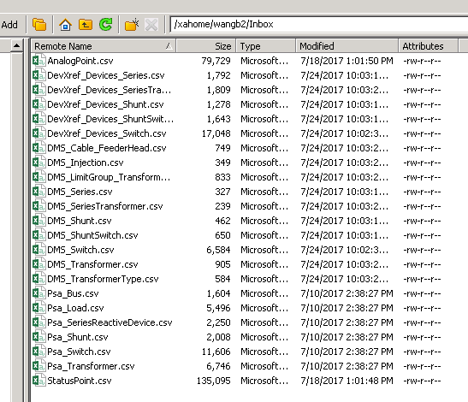

**Figure 11:** Open the file explorer for **DMSDT6AP01** Drop the **AnalogPoint.csv** and **StatusPoint.csv** files from the **PsaFiles** folder in ‘DMS Conversion’ into an **Inbox** folder stored within your home directory on DMSDT6AP01 (If one does not exist, then please create it). After the 2 files have been copied over, also copy over the newly generated files you built from the **DMSFiles** folder in ‘DMS Conversion’ into the same **Inbox** folder.



**Figure 12:** Run the script located in /xahome/xa21/Ben/dms_dbtool on dmsdt6ap01 once you have copied all files to the inbox folder.

The script and location is shown above.

You will be prompted for your username to locate the correct ‘Inbox’ folder, type it in and hit enter.

Once all jobs are committed into the system, check the oneline on DT6 to verify you are receiving a pop-out for DPF. If you see the pop-out, then the devices have been successfully added and linked across to GENe DMS.